Bubble Sort: Element will be sorted from the last

It is a linear sort algorithm. The name Bubble came because, element will be sorted from last one by one previous, like how bubble comes up in water from bottom to top.

It is a simple sorting algorithm that works by repeatedly stepping through the list to be sorted, comparing each pair of adjacent items and swapping them if they are in the wrong order.

Worst case performance
Best case performance

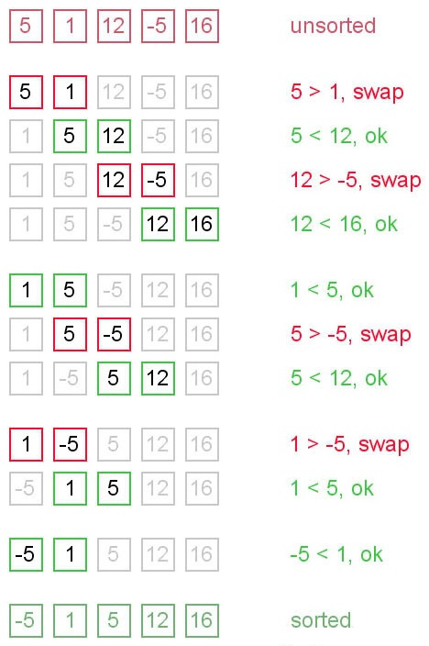

package com.altimetrik.algorithm;

public class BubbleSortWiki {

public static void main(String[] args) {
int a[] = { 2, 4, 1, 3, 6, 5, 10, 8 };

for(int i=a.length; i>0; i--) {
for(int j=0; j<i-1; j++) {
if(a[j]>a[j+1]) {
a[j] = a[j]^a[j+1];
a[j+1] = a[j]^a[j+1];
a[j] = a[j]^a[j+1];
}
}
Arrays.stream(a).forEach(System.out::print);
System.out.println("");
}
}

}

Selection Sort: Element will sorted from beginning

Selection sort is the simplest form of sorting an integer array.
In selection sort we first find out the smallest element in the array, then we place it in the first position. Now the first element is the smallest element in the array hence it is in its sorted position. Now take the next index, repeat the process of finding the smallest among the rest of elements, again place it in the index that you started with. Now the first and the second elements are in their sorted positions. Repeat the process for as many times such that the complete array becomes sorted.
In the figure below you can see a diagrammatic approach to follow selection sort.
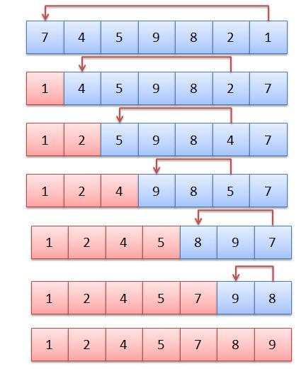
Worst case performance | О(n²)
Best case performance | О(n²)

It compares 1st element with rest of element. If any element is smaller, that element is swapped with 1st element and comparison continues.
Then compare 2nd element with rest……………….

Selection Sort Approach 1

package com.altimetrik.algorithm;

/**
* This sort has too many swapping which increases the time complexity
* @author Tchandrasekhar
*
*/
public class SelectionSort{

public static void main(String[] args) {
int a[] = { 3, 4, 2, 1, 6, 5, 10, 8 };

for (int i = 0; i < a.length-1; i++) {
for (int j = i + 1; j < a.length; j++) {
if (a[i] > a[j]) {
int temp = a[i];
a[i] = a[j];
a[j] = temp;
}
}
for (int array : a) {
System.out.print(array);
}
System.out.println("");

}

}

}
Selection Sort Approach 2
package com.altimetrik.algorithm;

/**
* This sort the reduces the swap by indexing technique
* @author Tchandrasekhar
*
*/
public class SelectionSortWiki {

public static void main(String[] args) {
int a[] = { 3, 4, 2, 1, 6, 5, 10, 8, 11 };

for (int i = 0; i < a.length-1; i++) {
int iMin = i;
for (int j = i + 1; j < a.length; j++) {
if (a[j] < a[iMin]) {
iMin=j;
}
}

if(iMin != i) {
int temp = a[i];
a[i] = a[iMin];
a[iMin] = temp;
} else {
System.out.println(a[i] + " is in sorted Position");
}

for (int array : a) {
System.out.print(array);
}
System.out.println("");

}

}

}

